signInAuthenticationFailed micorreo1@correo.com micontraFalsa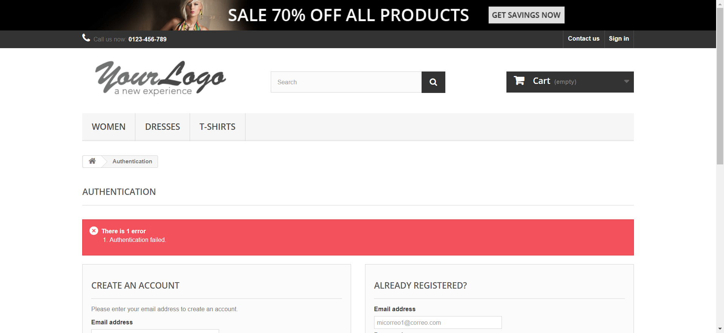

signInEmailInvalido testgmail.com ABCD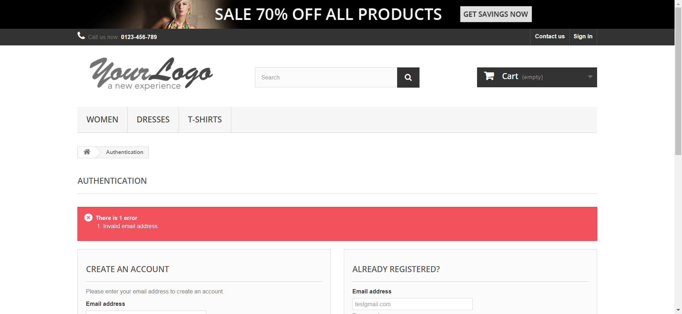

signInEmailInvalido test@gmailcom ABCD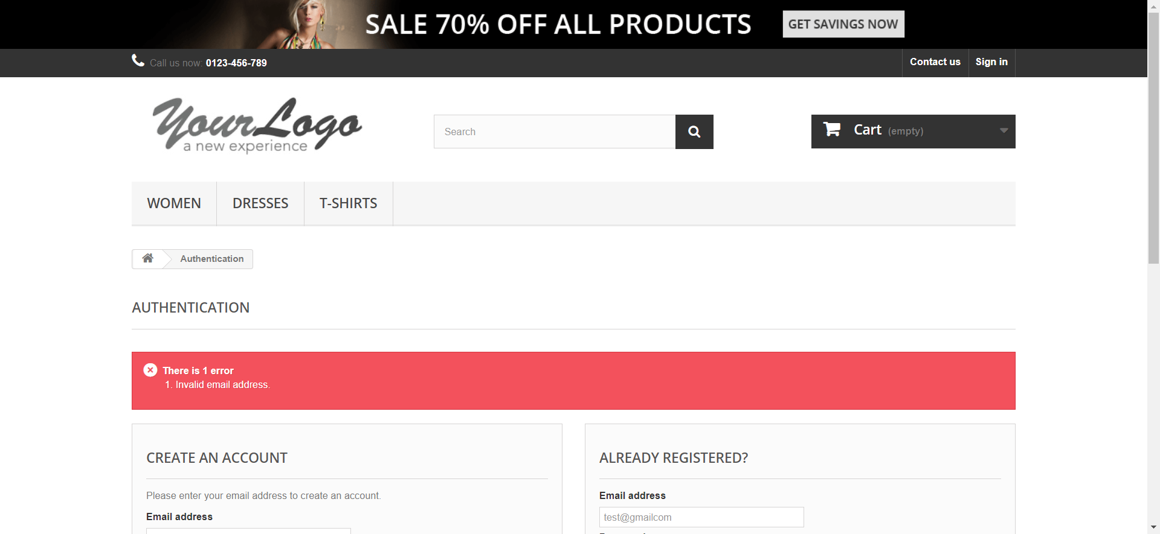

signInEmailInvalido test@gmail. ABCD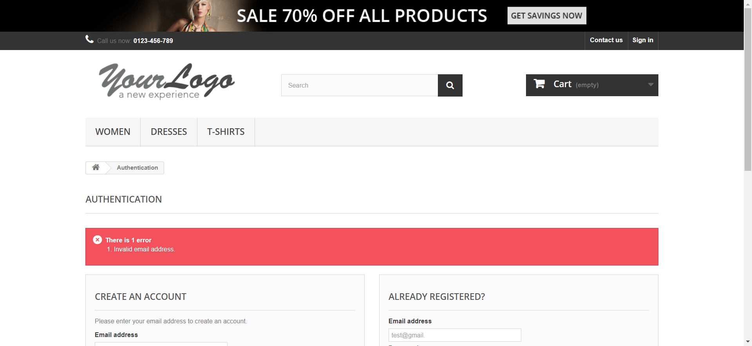

signInInvalidPassword test@gmail.com ABCD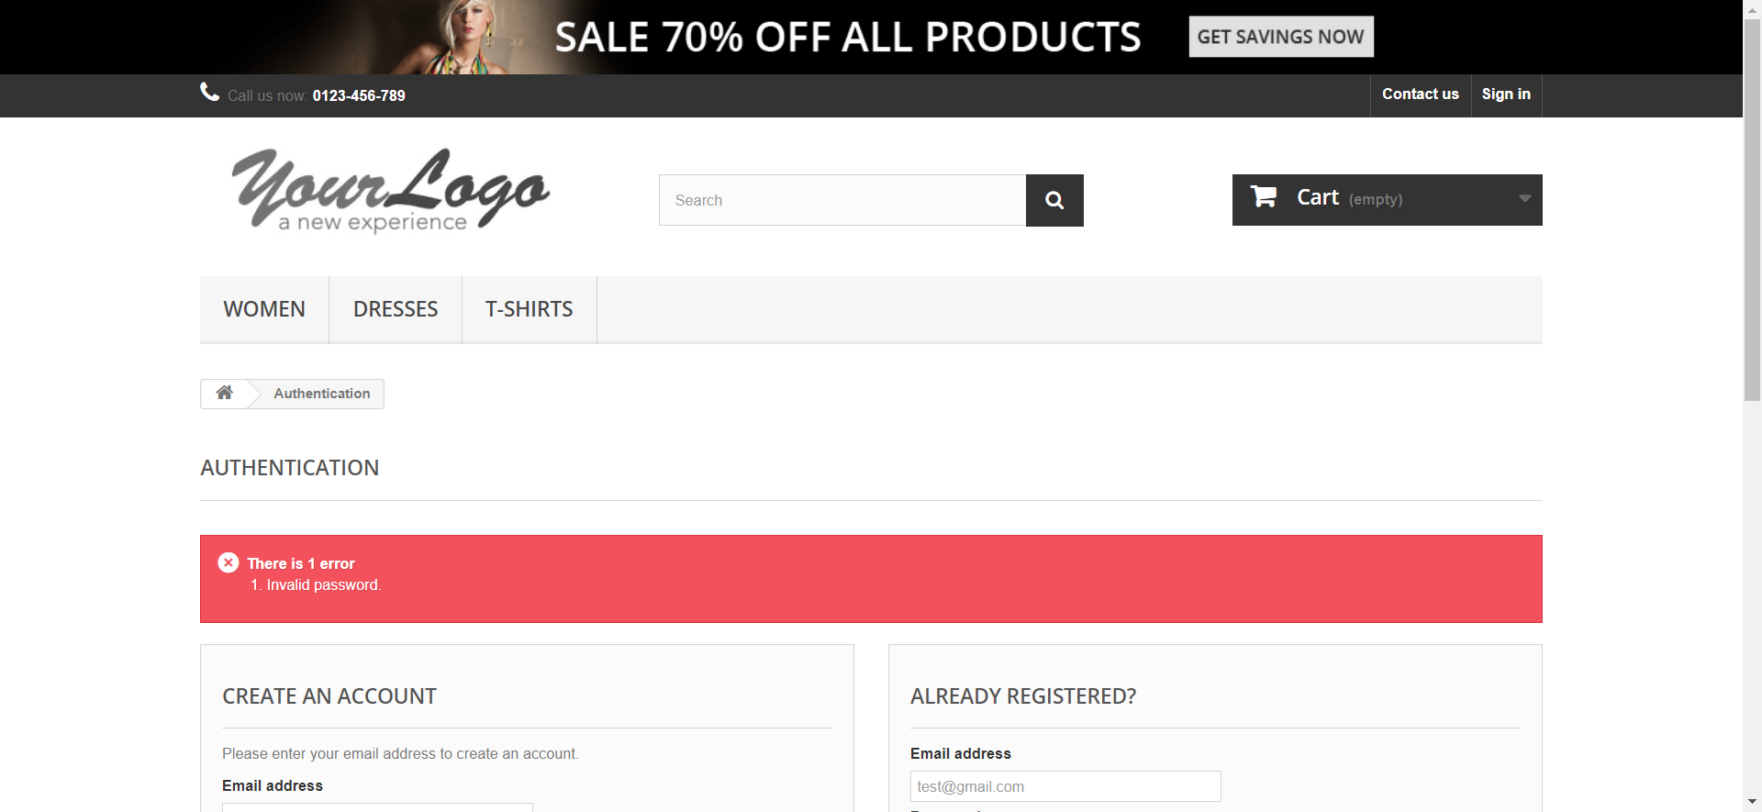

signInInvalidPassword test@gmail.com 1

signInInvalidPassword test@gmail.com 112a

signInRequiredEmail myp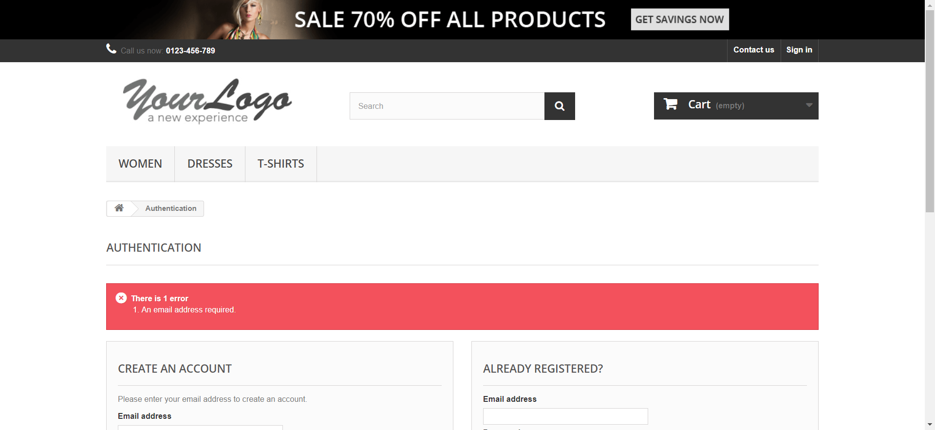

signInRequiredEmail myPassword

signInRequiredEmail 11

signInRequiredPassword micorreo1@correo.com 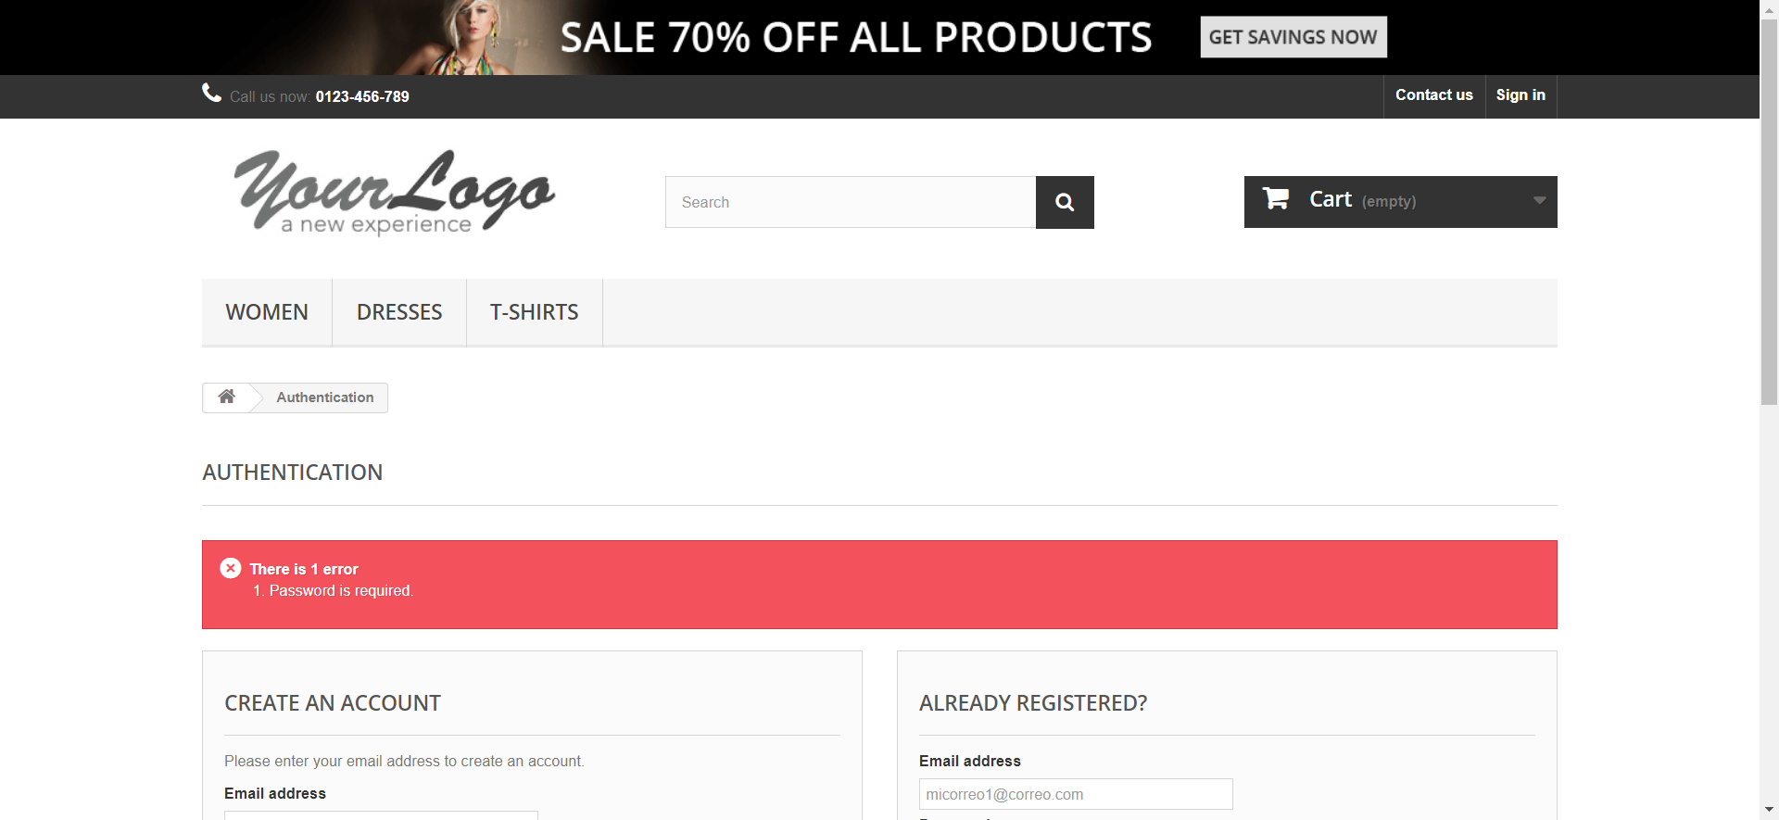

signInAuthenticationFailed micorreo1@correo.com micontraFalsa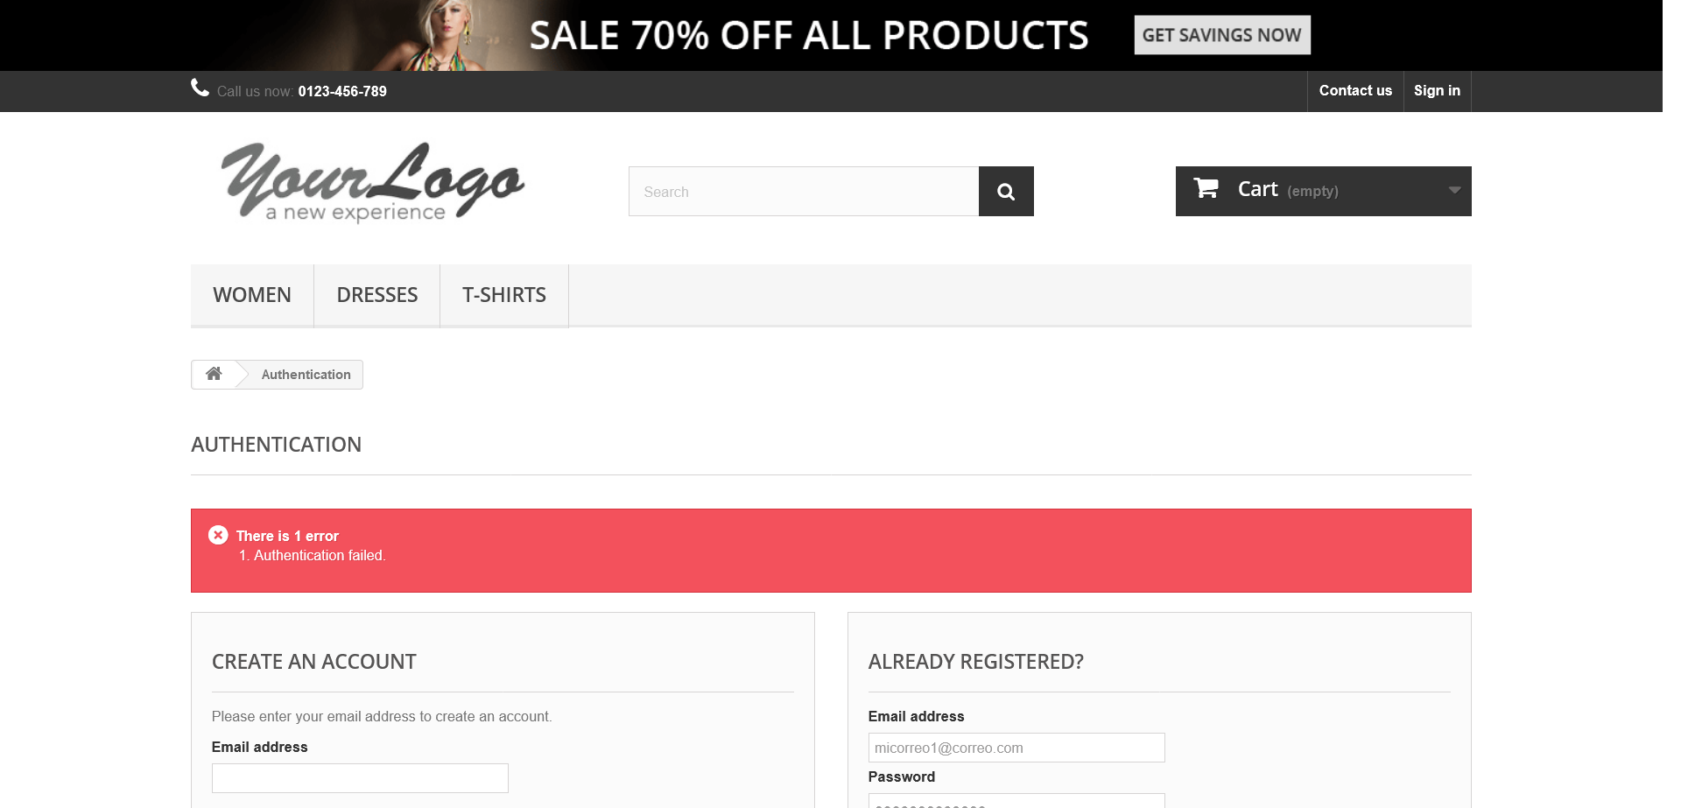

signInEmailInvalido testgmail.com ABCD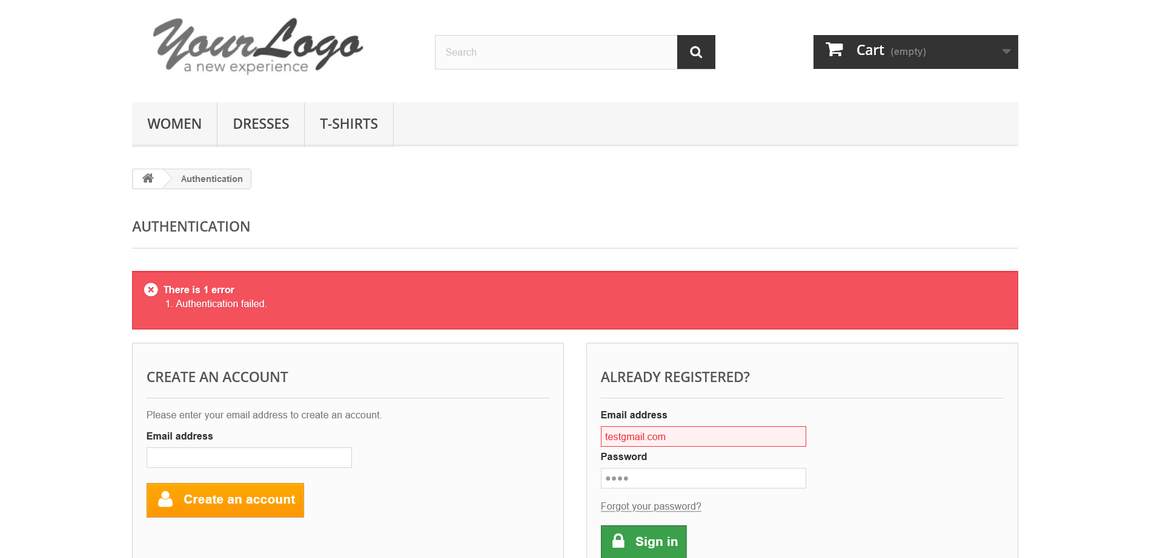

signInEmailInvalido test@gmailcom ABCD

signInEmailInvalido test@gmail. ABCD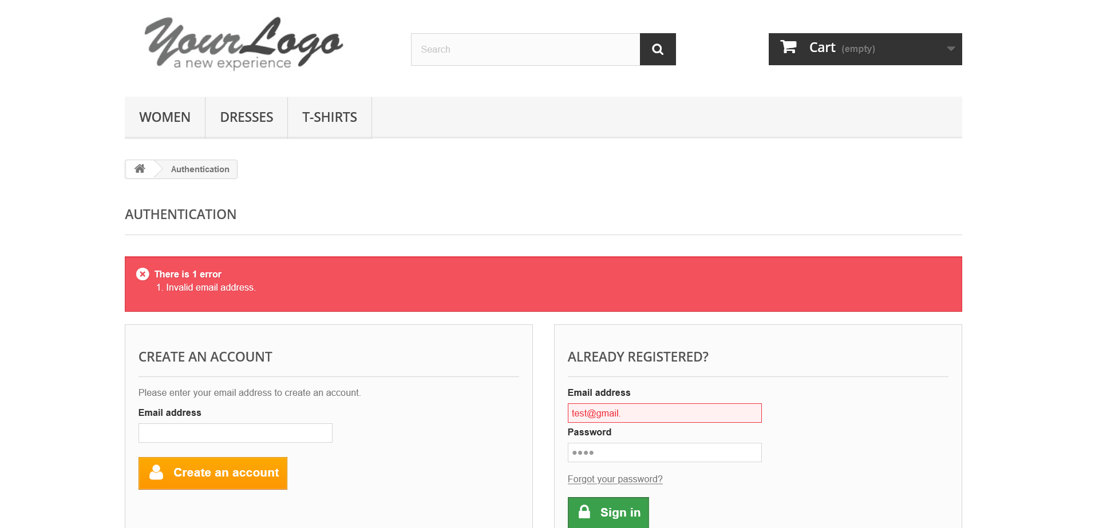

signInInvalidPassword test@gmail.com ABCD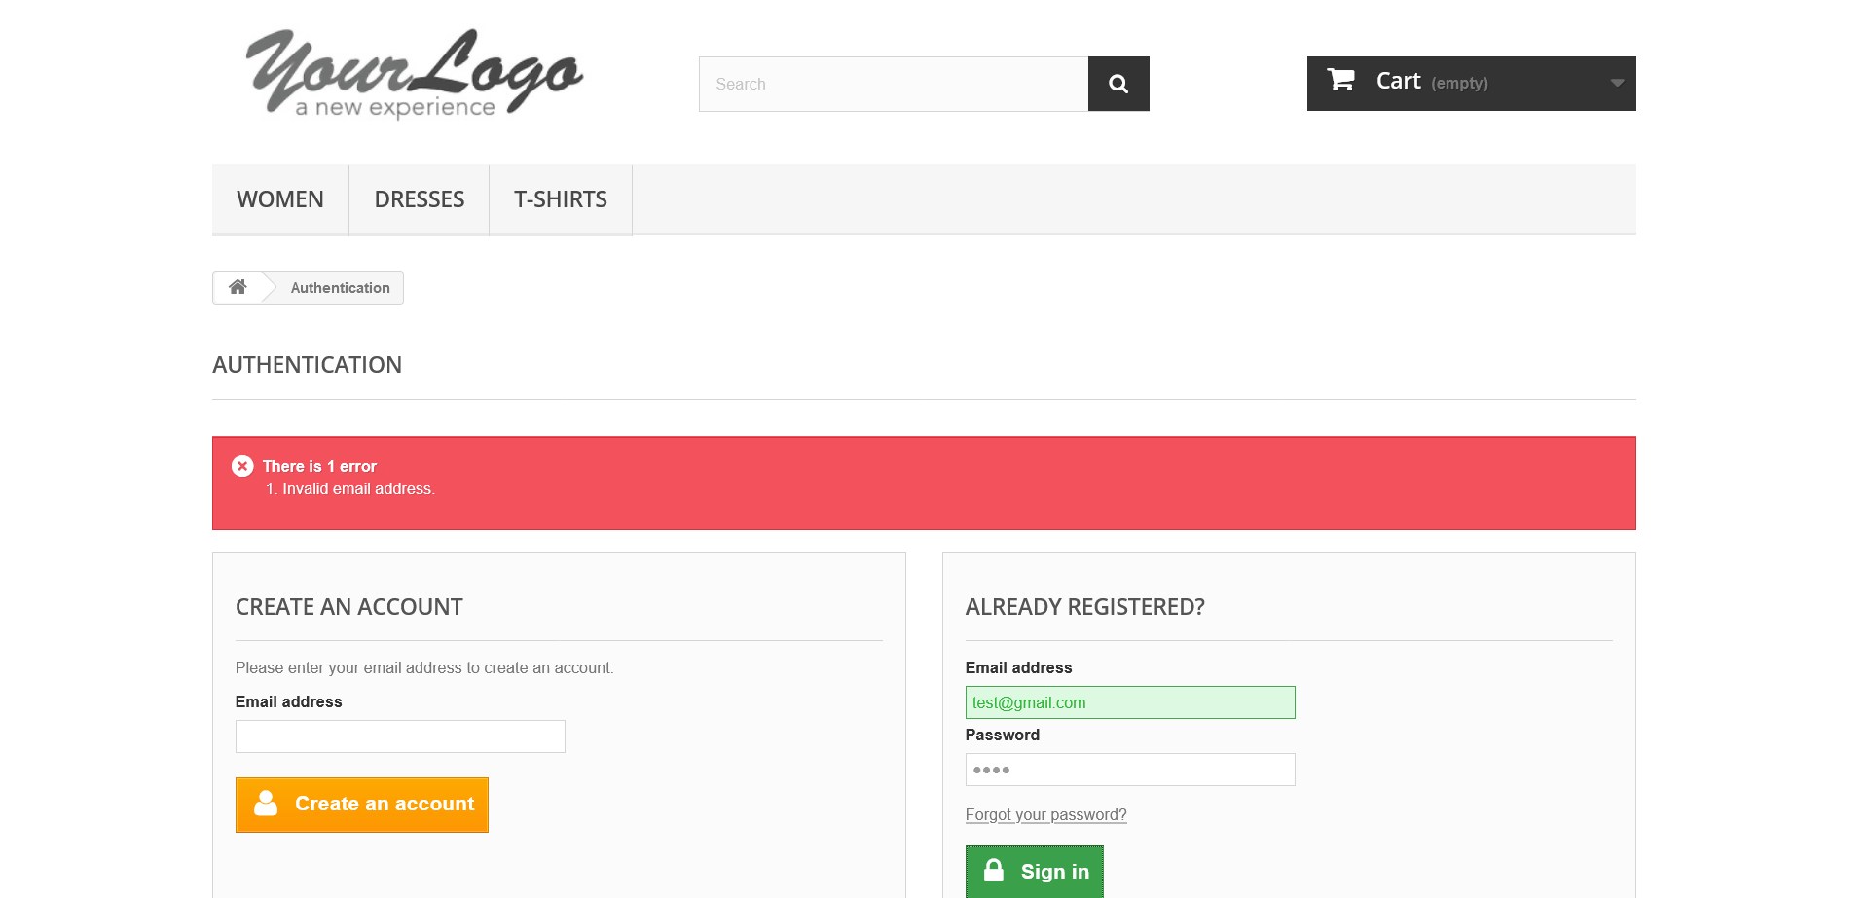

signInInvalidPassword test@gmail.com 1

signInInvalidPassword test@gmail.com 112a

signInRequiredEmail myp

signInRequiredEmail myPassword

signInRequiredEmail 11

signInRequiredPassword micorreo1@correo.com 